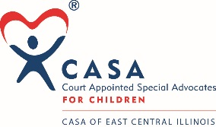

CASA of East Central Illinois
BOARD AGENDA
Sept. 9, 2020
4 pm

Mission statement
The CASA of East Central Illinois program is a not-for-profit corporation that advocates for the best interests of abused and neglected children brought into the Coles and Cumberland County Juvenile court systems.

- Call to Order – Marilyn Coles

- Reading of the Mission Statement – Marilyn Coles

- New Hire Social Media/Marketing – Gabby Comelleri

- Advocate Coordinator – Rebecca Austin

- Approval of July 2020 Minutes

- Change A Child’s Story – Kim Carmean

- Executive Director Report - Kim Carmean

- Financial Report – Kim Carmean

- New Board Member Vote – Stephanie Anderson

- COVID Ask Letter Results

- Committee Reports

- Executive & Nominating
- Budget & Finance
- Marketing & Outreach
- Fundraising

- Old Business

- New Business

- Adjournment

- Next CASA Board Meeting, November 11, 2020, 4 PM, Zoom

